

Running Active Net on Windows 10 with current supported devices

(v1)

ACTIVE Network, LLC

© 2016 Active Network, LLC, and/or its affiliates and licensors. All rights reserved. No part of this publication may be reproduced, transmitted, transcribed, stored in a retrieval system, or translated into any computer language, in any form or by any means, electronic, mechanical, magnetic, optical, chemical, manual, or otherwise, without prior written permission. You have limited permission to make hard copy or other reproductions of any machine-readable documentation for your own use, provided that each such reproduction shall carry this copyright notice. No other rights under copyright are granted without prior written permission. The document is not intended for production and is furnished "as is" without warranty of any kind. All warranties on this document are hereby disclaimed including the warranties of merchantability and fitness for a particular purpose.

ACTIVE Network, LLC

San Diego Corporate Office

10182 Telesis Court

San Diego, CA 92121

**About ACTIVE Network, LLC**

ACTIVE Network, LLC is a technology and media company that helps millions of people find and register for things to do and helps organizations increase participation in their activities and events.

For more information about ACTIVE Network, LLC products and services, please visit [ACTIVEnetwork.com](http://www.activenetwork.com/).

If you have any questions about this document, please contact the ACTIVE Net Support team using the information below.

**Phone**: 1-800-663-4991

**Email**: [activenetsupport@activenetwork.com](mailto:activenetsupport@activenetwork.com)

Website: <http://support.activenetwork.com/activenet>

## Running Active Net on Windows 10 with current supported devices

ACTIVE Net 16.2 now supports the Microsoft Windows 10 operating system. To run Active Net on Windows 10, the following application requirements must be met:

* Java: version 8 update 91
* Adobe Reader: 11.0.06 or later
* Flash: 12.0.0.44 or later

**Note**: For Windows 10, ACTIVE Net Admin Interface (AUI) does not support the Microsoft Edge browser (the default Windows 10 browser). Please use Internet Explorer 11 to open the AUI.

For most of the supported devices, installation procedures on Windows 10 are the same as for other Windows operating systems, except for the following devices:

* **Honeywell 7120** and **7580 scanners**. To install a Honeywell 7120 or 7120 scanner on your Windows 10 computer, see Installing Honeywell 7120 or 7580 scanner.
* **Epson TM-T88IV (POS Printer)**. Before installing an Epson TM-T88IV (POS Printer), see Checking whether your Prolific USB device supports Windows 10.

## Installing a Honeywell 7120 or 7580 scanner

If you have installed a Honeywell 7120 or 7580 scanner on Windows 10 with an incorrect driver, then under **Windows 10 > Device Manager > Other Device**, an exclamation mark icon (!) is displayed. Disconnect the device from your computer, and follow the instructions below to reinstall the device.

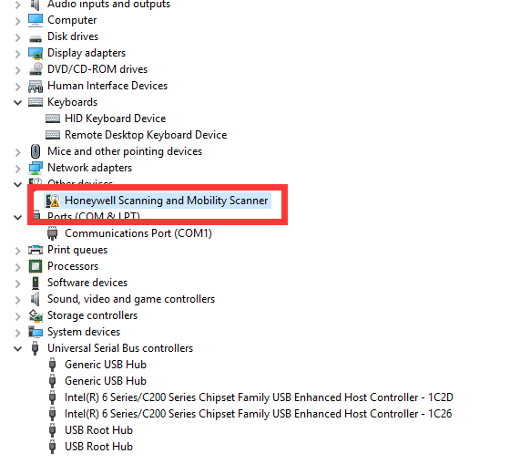

To install a Honeywell 7120 or 7580 scanner, execute the following steps:

* Open the Honeywell [How to get the scanner to communicate via virtual COM port / USB serial driver](http://hsm.force.com/publickb/articles/HSM_Article/How-to-get-the-scanner-to-communicate-via-virtual-COM-port-USB-serial-driver/?q=COM&l=en_US&fs=Search&pn=1) page.

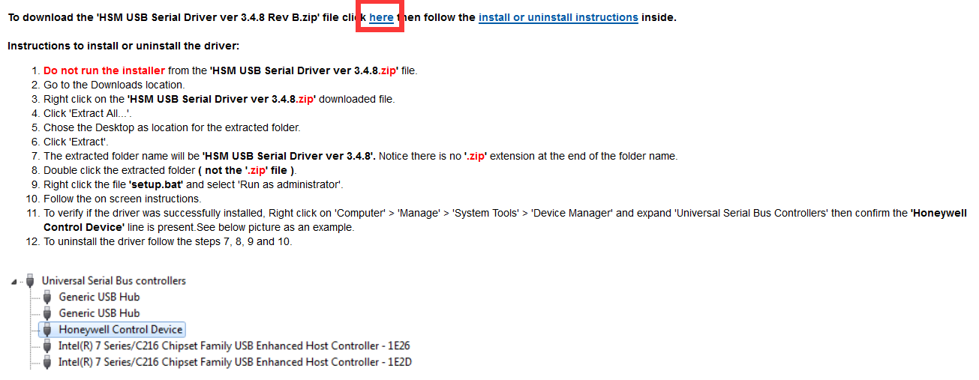

* Referring to the screenshot above, click the **here** link to download the latest driver.
* Unzip the downloaded **HSM USB Serial Driver** file.
* Open the unzipped **HSM USB Serial Driver** folder.

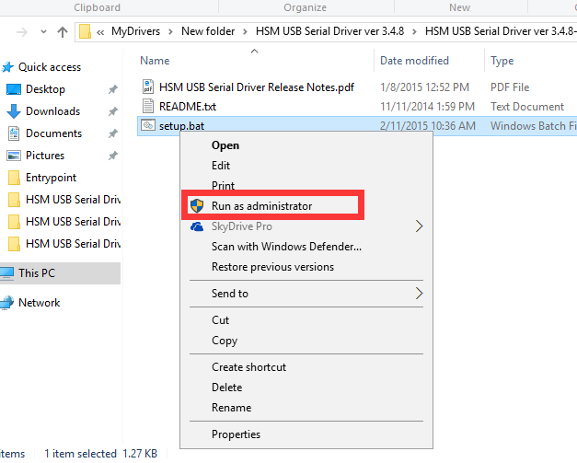

* Right click the **setup** BAT file and select **Run as administrator**.
* To verify if the driver was successfully installed, right-click on **Compute**r > **Manage** > **System Tools** > **Device Manager** and expand **Universal Serial Bus Controllers**, then confirm that **Honeywell Control Device** is present.



* Connect your scanner device to your computer, note the COM port and use the COM port to configure your ACTIVE Net entry point.

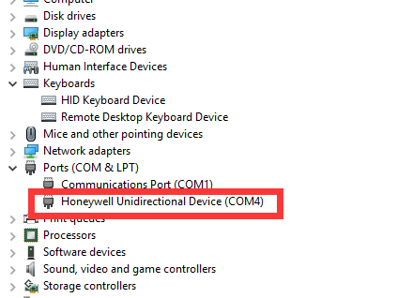

If no COM port is displayed,

* Right click the **setup** BAT file and select **Run as administrator**. The installer will detect the installed driver and offer to uninstall it; follow the instructions to uninstall it. Then follow the steps above to reinstall the driver.

## Checking whether your Prolific USB device supports Windows 10

To use an **Epson TM-T88IV (POS Printer)** on Windows 10, you must check whether your Prolific USB device supports Windows 10.

To check whether your Prolific USB device supports Windows 10, execute the following steps:

1. Go to the [PL2303 Windows Driver Download](http://www.prolific.com.tw/US/ShowProduct.aspx?p_id=225&pcid=41) site.

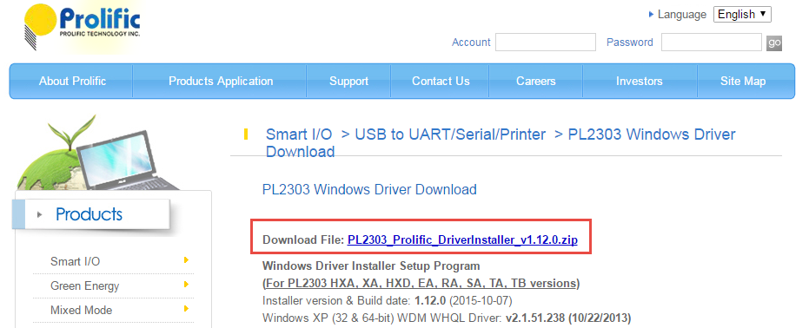

1. Click **PL2303_Prolific_DriverInstaller_v1.12.0.zip** to download the driver installation file.
2. Unzip the downloaded file.
3. Under the unzipped **PL2303_Prolific_DriverInstaller_v1_12_0** folder, open the **PL2303 Windows Driver User Manual v1.12.0.pdf**.

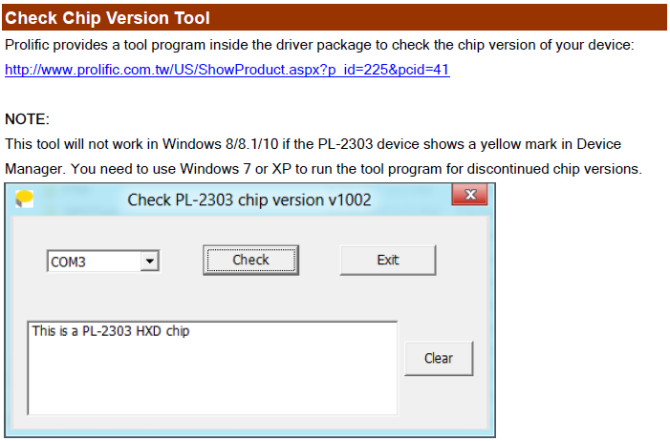

1. Under the **page 11** **> Check Chip Version Tool** section, follow the instructions to determine the chip version of your Prolific USB device.

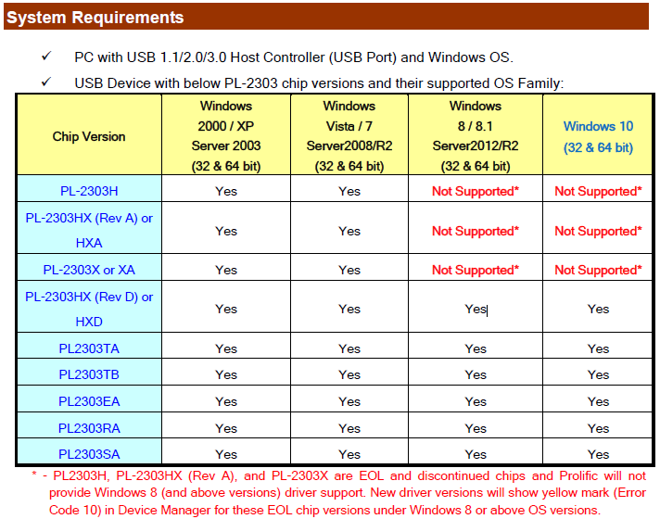

1. Under the **page 1 > System Requirements** section, check your chip version in the **USB Device with below PL-2303 chip versions and their supported OS Family** table.
2. If your USB device does not support Windows 10, refer to the **USB Device with below PL-2303 chip versions and their supported OS Family** table, and use a different supported USB device to connect an **Epson TM-T88IV (POS Printer)**.